What do firefighters wear UNDER their gear?
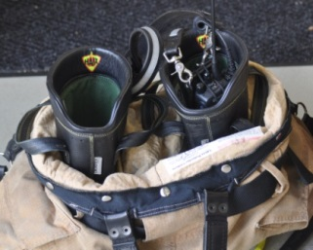
Some wear clothes made of lightweight cotton or a cotton/nylon/nomex blend when they are not responding to an emergency. Nomex is a type of fire-resistant material, which helps provide an extra layer of protection for the firefighter. Synthetic material is generally not worn underneath, because they can melt at high temperatures, and often do not 'breathe' as well as cotton or a blend would. In high-temperature situations, if the material against a firefighters' skin does not breathe, sweat can build up and steam can burn.
Boots - Firefighters wear rubber or leather boots. They have safety toes and shanks in them to prevent puncture and crushing injuries. The boots are waterproof, and are built with a fire-resistive liner, and a layer of insulation to keep the feet warm in cold environments, and cool in hot environments. Boots are generally 12-14" tall, and can have handles at the top to help the firefighter get their boots on fast.
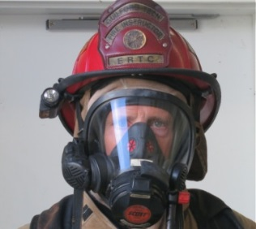
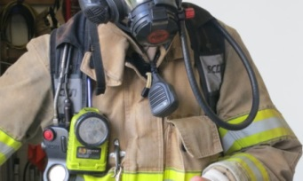
Coat – Coats have three-layers of material like the pants. Coats have large pockets for carrying equipment and usually have hangers, straps, and clips to hold flashlights, radios, and other equipment. Coats have large high collars to protect the neck of the firefighter. Coats use zippers, buttons, velcro, and clips or hooks to close. Reflective trim is on them for better visibility and safety.
Flash-hood – Made with a fire-resistive material such as nomex. The hood covers all the exposed areas of the face, neck, and ears when a firefighter is wearing their SCBA (air) mask. The hood also protects the head under the helmet from heat.
Helmet - Helmets come in various shapes, types, and colors. The special shape of the helmet is for protection from falling objects, and helps water flow over the back, so it does not go down the neck of the firefighter. Helmets may have a visor or face cover protect the eyes and face. Chin straps are also used to keep the helmet on the head.
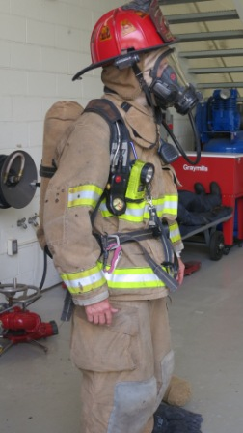
SCBA - Self Contained Breathing Apparatus helps a firefighter breathe fresh, clean air in a as in a fire. There are many parts to a SCBA. They have an Air Mask, Air Tank, and Regulation system. Air Tanks can hold 20 minutes to an hour of air. They can warn the Firefighter when their air is getting low, and help other firefighters find an injured or lost firefighter.
Gloves - Firefighting gloves are like oven mitts, but fingers can move easier. They help firefighters hold very hot things, and crawl around in a burning house without burning their hands. Gloves are mostly waterproof. The outside is made of leather that helps protect from sharp things and ripping.

